Try using the maps (bit.ly/communityinclusionmaps) to find information for your jurisdiction.

- Are there census tracts in your jurisdiction where more than 15% of the population over 5 years of age speaks English less than well?
  - If yes, which non-English languages are spoken?
- Pick a census tract. What percent of the population is over the age of 65? Over the age of 85? Under the age of 18? Under the age of 5?
- What disability or difficulty area is most prevalent in your area?
- What is the phone number of your Area Agency on Aging?
- What is the closest health or childcare facility to your place of work?
- How many and what types of Durable Medical Equipment claims are most prevalent in the zipcodes you cover?

Yes No
____________

____________
____________
____________
____________

____________

Look at the Community Inclusion in Colorado indicators list. How might you use this data to inform…
- Hazard planning and priorities in your HVA or THIRA?

- Relationship building and community-informed planning or training?

- Injects and objectives in your emergency exercises?

- Emergency Public Information and Warning (i.e. Alerts, Notifications)

- Resource ordering?

What other indicators for access and functional needs (AFN) or for diverse communities would be helpful to map? To be knowledgeable about?

The Community Inclusion in Colorado Maps use data indicators that cover the whole state.
What local data do you have that speak to diverse and functional communities or resources in your jurisdiction specifically?

What promising practices does your jurisdiction use to address access and functional needs in emergencies?

Access & Functional Needs Influencers
C_________________ C_________________
M________________ H_________________
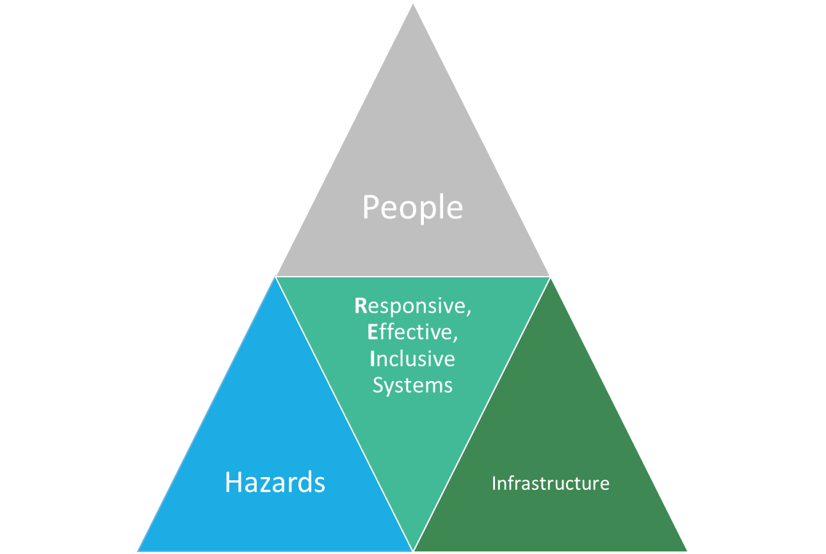
I__________________ I__________________
S_________________ E_________________
T_________________

Colorado Community Inclusion Maps
http://www.cohealthmaps.dphe.state.co.us/colorado_community_inclusion/
OR http://bit.ly/communityinclusionmaps
Maps are also available through CO-SHARE and CDPHE’s website

CDPHE’s Response Map (with Community Inclusion Indicators)
http://arcg.is/1MG30gL

For more CICOmaps information/support
Aimee Voth Siebert (aimee.vothsiebert@state.co.us)
Devon Williford (devon.williford@state.co.us)
Julia Beems (Julia.beems@ucdenver.edu)

